Week 10 Tides Labs
Tides
For the next set of questions use the simulation below (scroll to bottom of website page). Click the check boxes to turn features on and off.
https://beltoforion.de/en/tides/simulation.php
1. What do the yellow (orange) arrows coming from off the screen represent?
2. What to the small white and orange arrows coming from Earth represent?
3. How many water bulges are created by the gravity of the Moon?
4. How many water bulges are created by the gravity of the Sun?

Use the following link for the link below.
https://iwant2study.org/lookangejss/02_newtonianmechanics_7gravity/ejss_model_gravity01/gravity01_Simulation.xhtml
Click on down arrow shown in the attached screenshot then pick on the “y vs t due to moon” simulation. This will show the height of the tides compared to the orbital positions of Moon, Sun, and Earth.
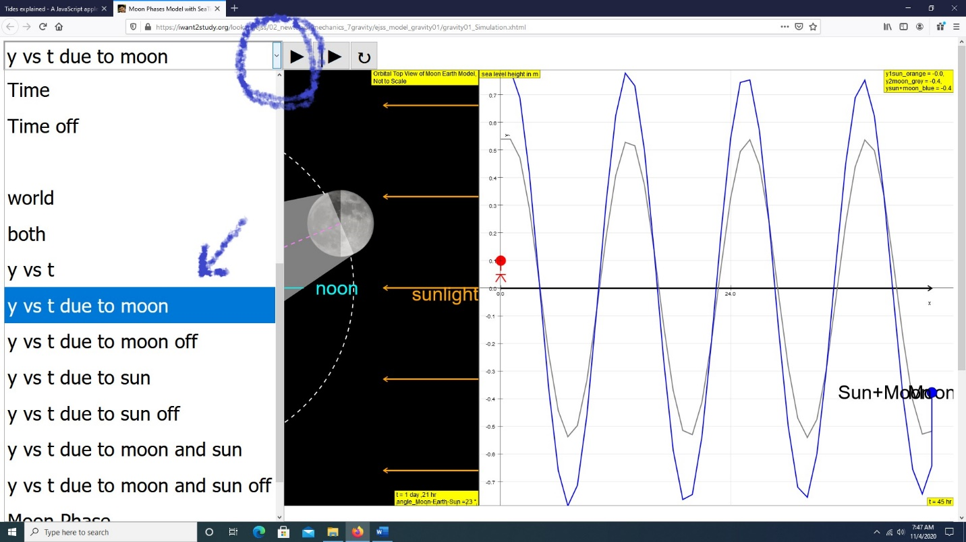

Click the play button next to the down arrow and what the orbit and daily height of the tides.

5. Are the tides always the same height (high and low tides)?
Stop the simulation with the play button, pick the down arrow and select the “y vs t due to moon and sun”.
6. Are the tides always the same height (high and low tides)?
7. From the lecture and chapter readings on tides, what sort of tide system is being simulated (diurnal, semi-diurnal, mixed)?

Put these questions and answers (along with pictures you took of the sphere and tide plane) into the lab report and upload the file to the Tide Lab Report assignment in Blackboard / Labs area.

